LINUX - 02

- Launch one aws ec2 and install jenkins.
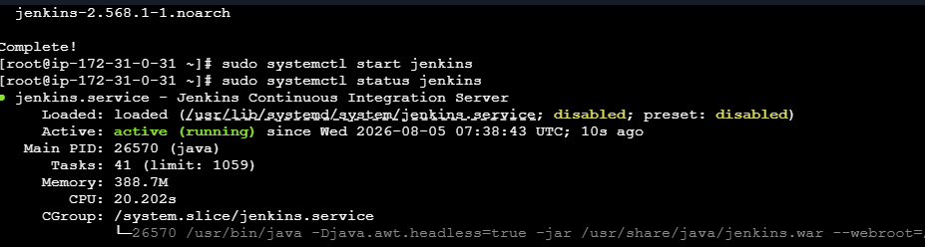
- Setup Apache Tomcat on Ubuntu Virtual Machine
